Log Book

James Skett

2018

Contents

26th February 3

28th February 3

1st March 3

3rd March 4

4th March 4

6th March 5

8th March 6

9th March 6

12th March 6

13th March 6

14th March 7

16th March 7

19th March 7

20th March 7

21st March 8

22nd March 8

24th March 8

26th March 8

27th March 8

5th April 8

6th April 9

# 26th February

I was supposed to have the DirectX window set up and working today but encountered a few problems the code was running but no screen was appearing.

# 28th February

I have managed to get the DirectX window to display on the screen working with the pixel and vertex shaders to render a box inside the viewport.

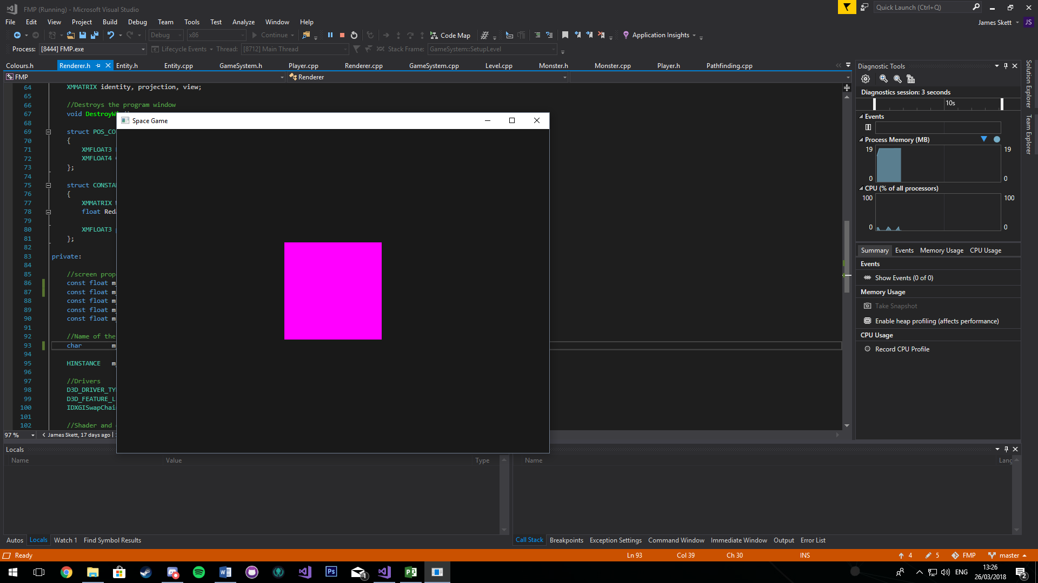

# 1st March

Today I was supposed to have the whole level sorted and rendered on the screen, but I realised I needed to render in an orthographic view, so I spent the day working on that making sure that it ran correctly and looked how it should. Having the orthographic view doesn’t change much just means that no matter what z coordinate the size and perspective wont change. It basically looks the same as the screenshot above.

# 3rd March

Today I fixed the object transformation code, so I was able to scale rotate and translate the objects on screen correctly. The problem was I was doing the transformations in the wrong order. I was doing rotation first then translation then scale, the correct order is scale rotate then translate.

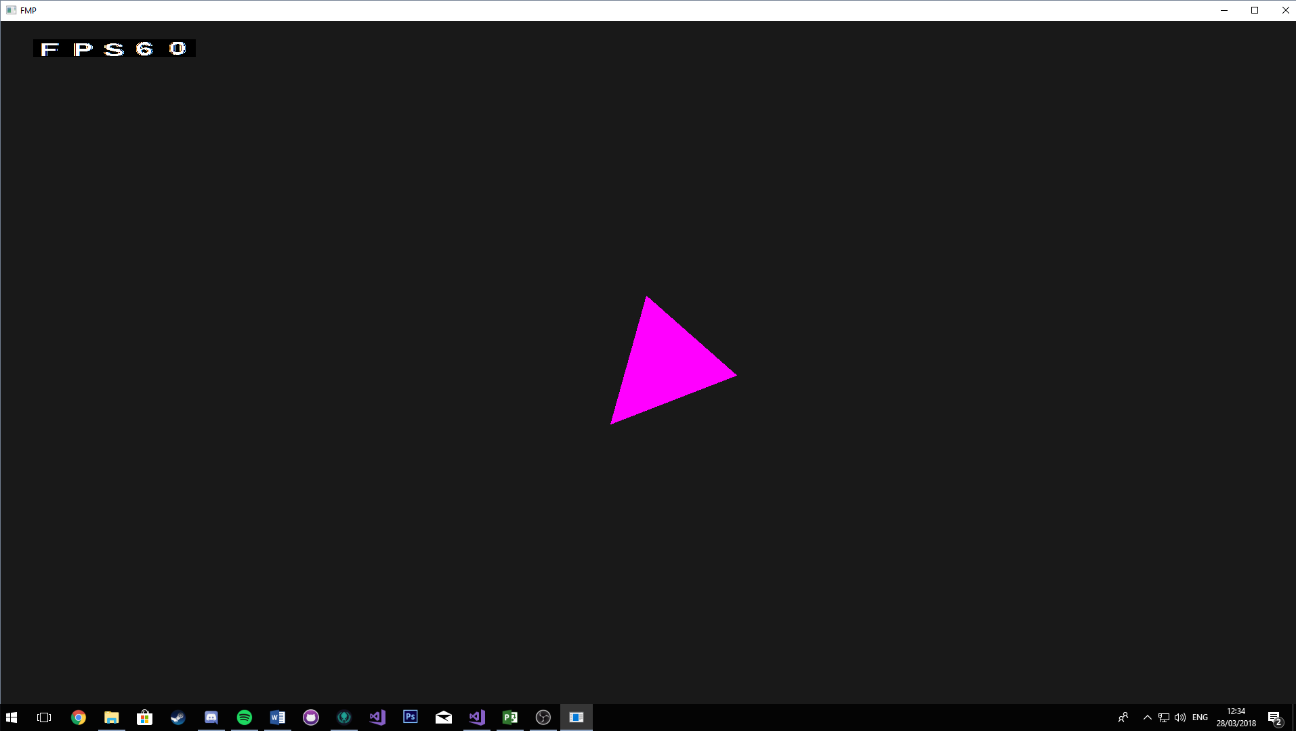

# 4th March

Today I wrote some code that will read a text file and store the data in a vector of strings. This will then allow me to loop through the data and place a tile based on the current ASCII character the loop is on.

# 6th March

I have now added a function that loops though the level data that was got from the text file and create a tile based on the ASCII character. It then positions the tiles next to each other as they are in the text file. I had to fiddle around with the numbers a bit to get them to spawn in the correct positions and be next to one another without any gaps.

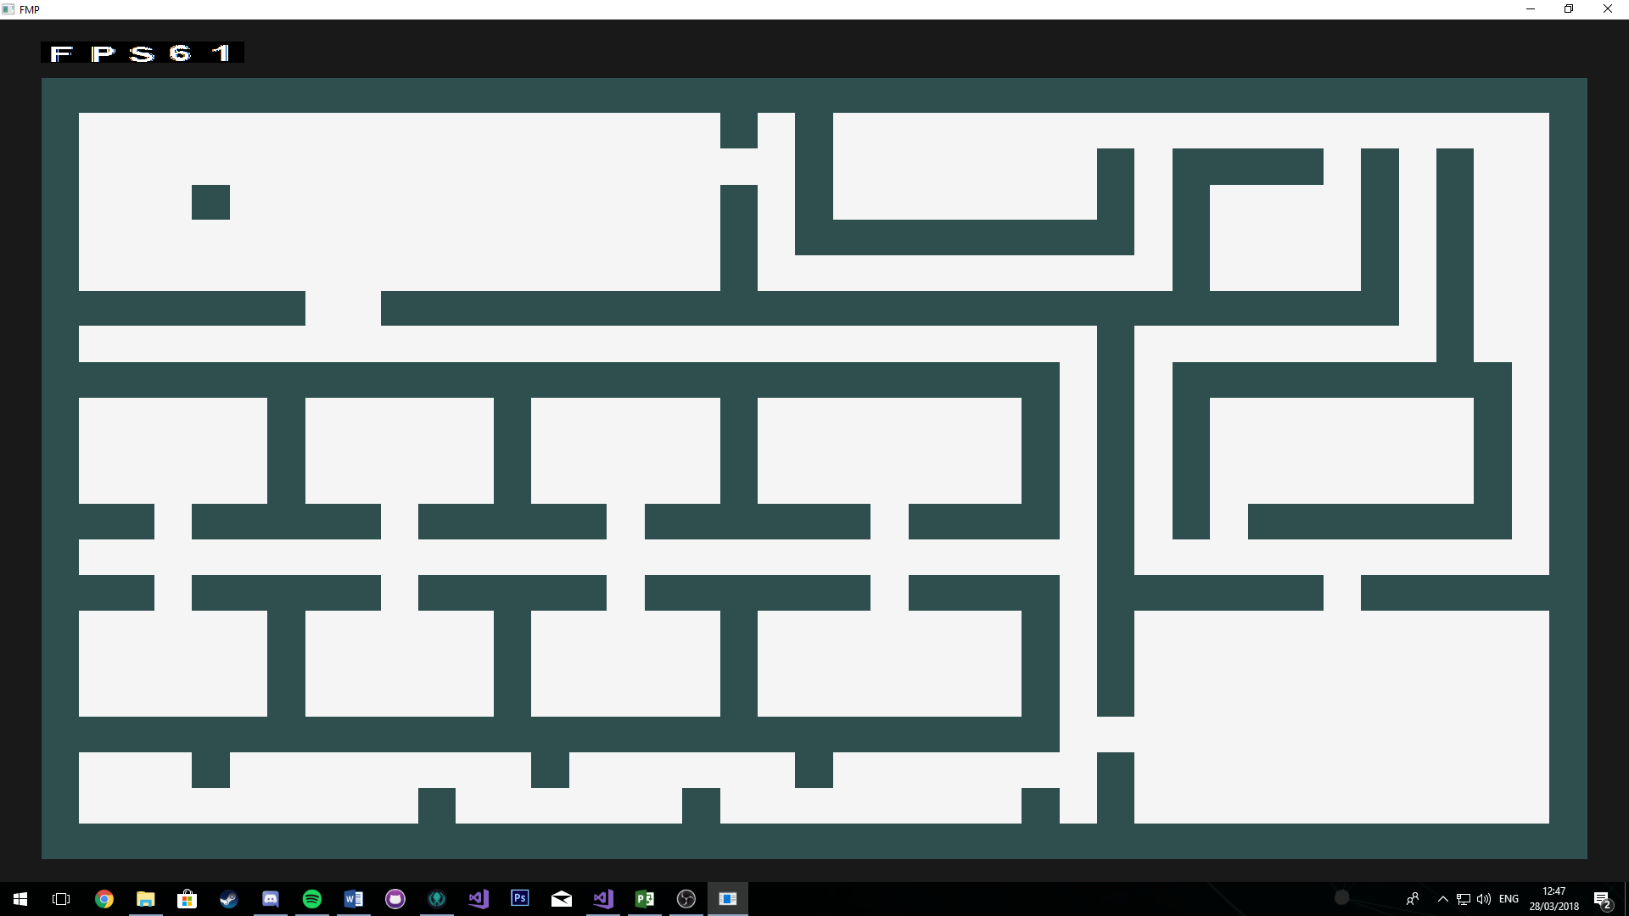

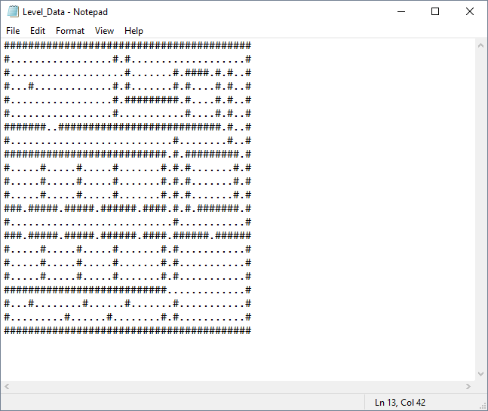

# 8th March

Today I added properties for the walls and player collisions, at this moment in time I am guessing the width and height of the objects this may change in the future. Currently the AABB collisions test is not working, the test is alternating between returning true and false when it should just be returning false.

# 9th March

Box collisions are now working as they should I have now started to work on getting the player to stop moving when colliding with a wall. I was trying to get the direction the player was from a tile and stop them moving based on this when they collide with a tile, but I couldn’t get that working. I found a much better way of doing it, I check for collisions when the player move is called and if there is a collision return the player to the previous position. This worked but the player would get stuck.

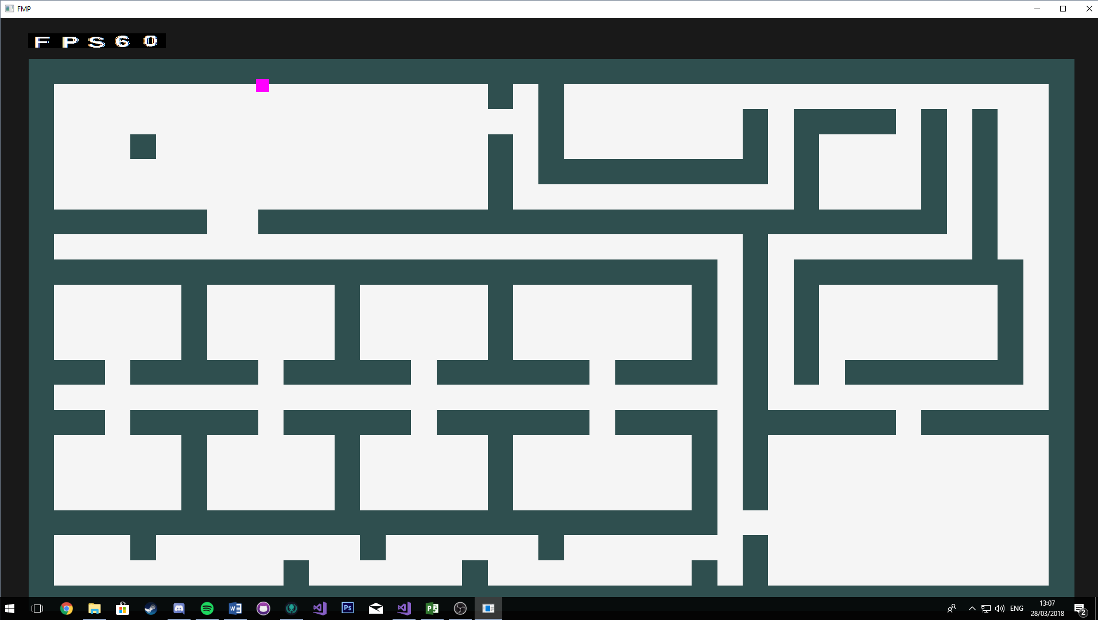

# 12th March

I realised that the way I was creating my level wasn’t the best way of doing it. I was creating 2 separate vectors one to store the walls and one to store the floor tiles. Now I created a Tile class that has 2 child classes wall and floor. I am then creating one vector called a tile map that holds all the tiles, but I pass in either a floor or a wall object. I use an index to differentiate between the two.

# 13th March

The collisions are now working as I want them to, I think the change in how I am storing all the tiles have made a difference because I didn’t change how the collisions where being done.

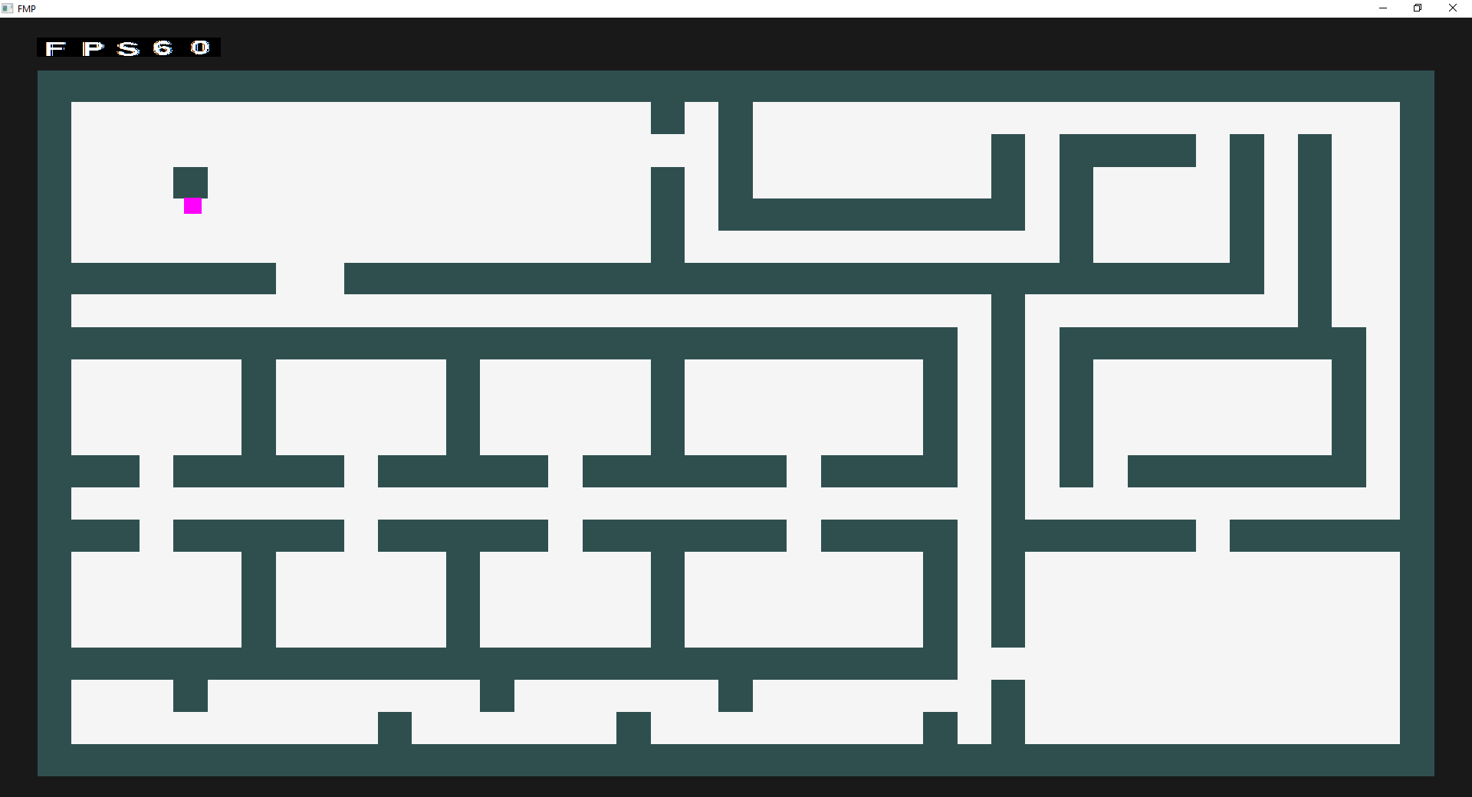

# 14th March

I added a monster class and a pathfinding class. The monster class will be where the main AI will be done. I added a pathfinding class so that I can start on the first AI behaviour. I have never done A* pathfinding so I need to do a lot of research.

WENDERLICH, R., 2018. Introduction to A* Pathfinding [viewed 14 March 2018]. Available from: <https://www.raywenderlich.com/4946/introduction-to-a-pathfinding>

I started by creating functions to find the starting tile and looking at what the distance is between adjacent tiles.

# 16th March

I am now calculating the F, G and H values that the algorithm will used to find the shortest path. I can calculate the H value easily by using the Manhattan distance. However, I am having trouble calculating the G value for new tiles that need to be checked as they are supposed to be added up based on the parent tile.

# 19th March

I have implemented the algorithm to how I understand it, but it doesn’t work how it should. No path is being found. I am going to look at the tutorial that was given during my Artificial intelligence unit this year and that may be able to help me understand it more.

# 20th March

After looking at the tutorial I mentioned previously I have pretty much redone the algorithm. I now have a node class that will have a parent node so that when I find a path I can easily retrace it as well as access the parents G value. I am still testing the algorithm but I understand it a lot more now.

# 21st March

The pathfinding algorithm is working but it is not finding the quickest path to the target. I have a couple of videos showing the results I get from the algorithm.

# 22nd March

I have now fixed the pathfinding algorithm the problem I had was I was sorting the open list of tiles in order of their F costs, but I was sorting them from low to high then accessing the last element in the vector. So, I just flipped the way it was being ordered and it now works fine. I have a video showing the working algorithm.

# 24th March

I was having trouble making to player rotate towards the mouse. I found out I need to convert the mouse coordinates into the same screen space as the game and then use the screen space coordinates for the player in order to rotate the object correctly. Look at video to show it working.

I also added a random wander behaviour to the monster class, so it moves around the level by itself.

# 26th March

I have added a new projectile class for one of the players attacks. The projectiles shoot function is not working currently working on a fix.

# 27th March

Bullets are now shooting correctly I was passing in the wrong direction values so was a quick and easy fix.

I have started to look into ray casting this is so I can get a field of view as well as line of sight for the player and monster.

# 5th April

After a lot of research and code that doesn’t work I have finally managed to get line of sight implemented into the project it works well I have made a video to show it.

# 6th April

I have added a visual representation of the view cone was quite easy to implement. However the line of sight code doesn’t work as it should at 0 degrees rotation up to 45 degrees rotation so need to look into that.

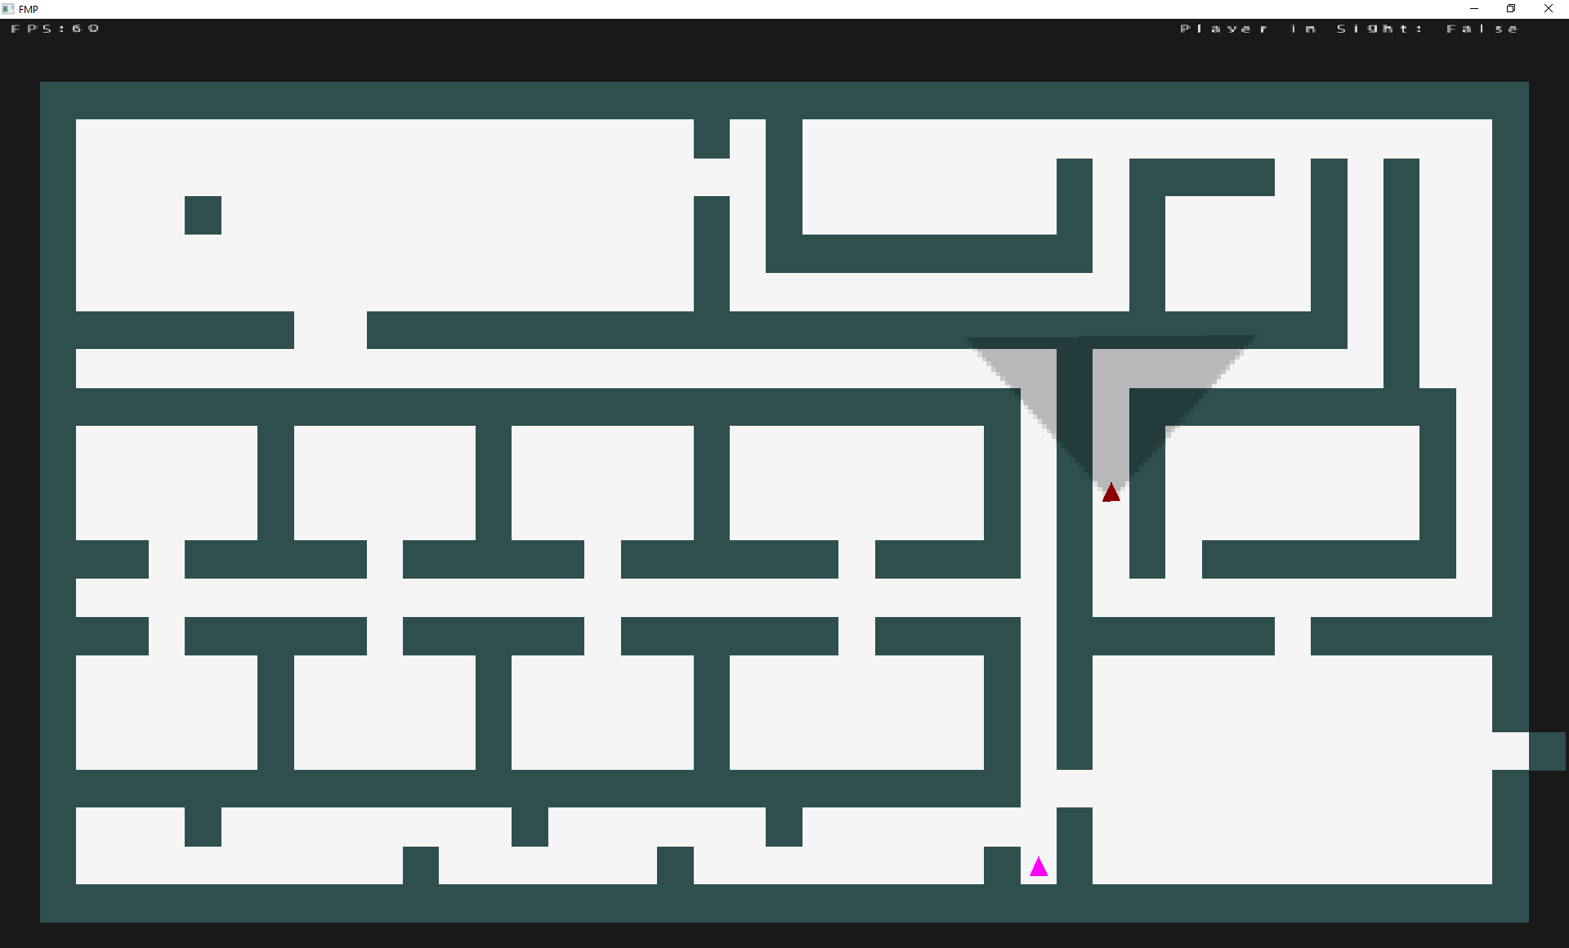

# 7th April

I have implemented the chase behaviour for the monster AI it works well. I have taken a video to show it working.